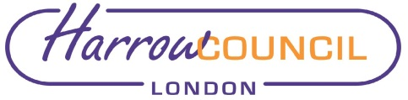

REPORT FOR: |  | COUNCIL
 | Date of Meeting: |  | 30 September 2021
 | Subject: |  | Decisions taken under the Urgency Procedure - Council
 | Responsible Officer: |  | Hugh Peart – Director of Legal and Governance Services
 | Exempt: |  | No
 | Enclosures: |  | None

In accordance with the delegations to Chief Officers, the Leaders of each of the Political Groups on the Council were consulted on the following urgent decision, which was approved on behalf of the Council, on the date below as it required action prior to this meeting.

9 March 2021 – Membership of the Chief Officers’ Employment Panel

It was agreed that the membership of the Chief Officers’ Employment Panel be increased from 5 to 7 (4 Labour Members, 3 Conservative Members) in order to facilitate greater diversity on the Panel.

FOR INFORMATION

Contact:
Elaine McEachron, Democratic & Electoral Services Manager
Tel: 020 8424 1097
E-mail: elaine.mceachron@harrow.gov.uk

Background Papers: Urgent Decision Form.

